East Point College of Engineering & Technology
Department of Computer Science & Engineering
Cloud Computing Lab – Azure Blob Storage

Aim
To create an Azure Storage Account, configure a Blob container, upload a file to the container, and generate a Shared Access Signature (SAS) to provide temporary access to the uploaded blob.

Procedure
- Sign in to the Azure Portal.
- Search for Storage accounts in the search bar.
- Click + Create.
- Select your Subscription.
- Choose or create a Resource Group (e.g., deepak).
- Enter a Storage account name (e.g., eastpoint2).
- Select the Region.
- Choose Performance: Standard, and Redundancy: Locally Redundant Storage (LRS).
- Leave the remaining settings (Advanced, Networking, Data Protection, Security, Encryption, Tags) as default.
- Click Review + Create.
- Click Create and wait for deployment.
- Click Go to Resource.
- Under Data Storage, select Containers.
- Click + Add Container.
- Enter the container name (e.g., mycontainer).
- Keep Anonymous access as Private (no anonymous access).
- Click Create.
- Open the container.
- Click Upload and select a file (e.g., python prog.pdf).
- Verify that the file appears in the container.
- Open the uploaded blob to view its properties.
- (Optional) Generate a Shared Access Signature (SAS) to provide temporary access to the blob.

Screenshots

1. Storage Account – Containers View
The screenshot below shows the storage account "eastpoint2" with two containers: the system-generated $logs container and the manually created mycontainer, both set to Private access.
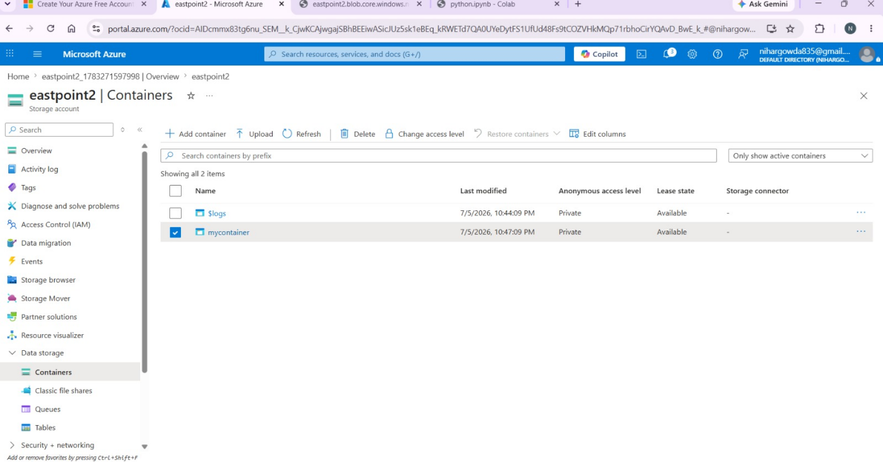

2. Blob Properties and SAS Token Generation
The screenshot below shows the uploaded blob "python prg.pdf" inside mycontainer, along with a generated SAS token and SAS URL, which grants time-limited, read-only, HTTPS-only access to the file.
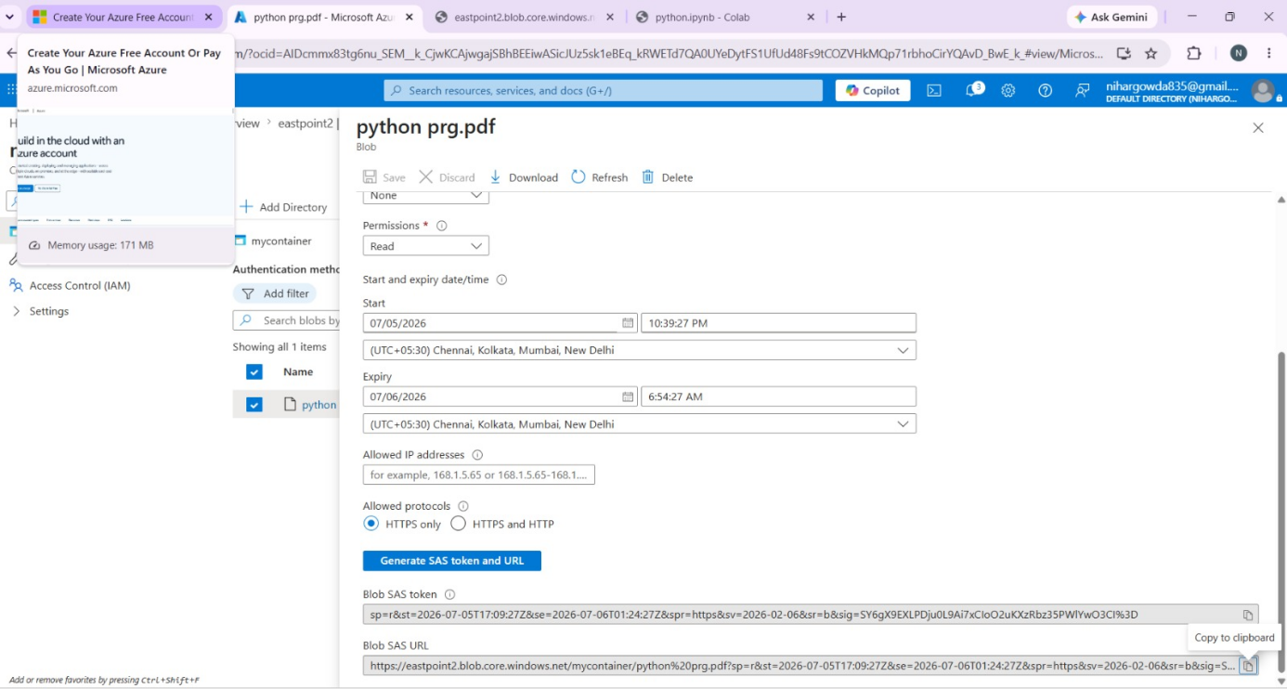

Result
An Azure Storage Account and a private Blob container were successfully created. A file was uploaded to the container, and a Shared Access Signature (SAS) URL was generated to provide secure, temporary, read-only access to the blob without making the container public.

